
Zimbabwe Health Interventions (ZHI)
Emerald Office Park Number 30, The Chase,
Corner 2nd St. Extension & The Chase (West)
Mount Pleasant, Harare, Zimbabwe

REQUEST FOR PROPOSAL (RFP)
FOR
SUPPLY AND DELIVERY OF (218) TWO HUNDRED AND EIGHTEEN UNISEX HEAVY DUTY 26 INCH BICYCLES

Tender/RFP Number: | ZHI.ACCE.2023.08.514
Submit Proposal to: | procureement@zhi.co.zw
Date of Issue of RFP: | 10 August 2023
Firm Deadline for Proposal Submission: | 18 August 2023
Approximate Date of Contract Award: | 15 September 2023

Method of Submittal:
Respond via e-mail to the email provided above, with attached proposal document in MS Word / pdf format. Documents should not be more than 2MB in size.

- INTRODUCTION
Zimbabwe Health Interventions (ZHI) is a local Zimbabwean non-profit human development organization whose mission is to help the Government of Zimbabwe achieve its health-related goals, with a focus on contributing to HIV/AIDS epidemic control using comprehensive and sustainable human development approaches; conducting research that will guide/inform policy and development of innovative interventions for human development in Zimbabwe. ZHI is currently implementing two 5-year programs funded by the US Agency for International Development (USAID). For more information, please visit www.zhi.co.zw.

- PURPOSE/SCOPE OF WORK
With funding from the United States Agency for International Development (USAID) for the ACCE-
Accelerated and Comprehensive HIV Care for Epidemic Control in Zimbabwe (ACCE) project, the ZHI now invites potential and eligible service providers to submit comprehensive proposals for the Supply and Delivery of NEW, Bicycles as follows:

# | Item and Summary Specifications | Quantity
1 | Unisex bicycles 26 inch, 1 speed | 218

- INSTRUCTIONS AND TERMS FOR BIDDERS

  - By submitting a bid, all vendors certify that the person(s) involved in the preparation and collation of the proposal and/or quotes were or are in no way associated or have any Conflict of Interests with the initial preparation of the solicitation, the tender documentation, or the subsequent evaluation, assessment, analysis, management, and decision-making process of this tender.

  - Language - the quote, as well as all correspondence and documents relating to the offer shall be in English.

  - The Quotation should include the following:
    - Price shall be quoted in US dollars (US$) only and duty free.

    - Prices for the requested goods/services should include all associated fees (such as shipping fees) and taxes (including VAT, if applicable), but priced as a separate line item in the submitted quote. It will be assumed that all quotes will be inclusive of all applicable fees and taxes if the bidder fails to separate out these costs.

    - Bid Validity Date - All information submitted in connection with this RFP will be valid
for ninety (90) days from the RFP due date and not subject to variation on any account during the Bidder’s performance of the final Contract unless another time is specified in the addendum of the RFP. This includes, but is not limited to items quoted, cost, pricing, delivery timelines, terms and conditions, service levels, and all other information.

  - If your firm is awarded the contract, all information in the RFP and negotiation process is contractually binding. No submission will be considered for any discovered omissions from the Bidder(s).

  - ZHI does not bind itself to accept the lowest tender price and reserves the right to reject all submissions, in whole or in part, enter into negotiations with any party, and/or award multiple contracts.

  - Tenders MUST be received on or before the closing date and time and all bids received after the closing date and time may not be considered.

  - ZHI will issue a Purchase Order to the selected winner(s) that shall state the items to be purchased, the location to which the items should be delivered, the specific timeframe within which the order should be completed, and a fixed price for the items to be purchased (including delivery costs). The Purchase Order will become a legally binding contract when it has been formally signed by both ZHI and the winning Vendor. A full list of the Terms and Conditions of the final Purchase Order are included as Attachment A to this RFP.

  - To ensure that the same level of information is conveyed equally to all suppliers, ZHI reserves the right to share questions and responses with all other suppliers.

  - All responses and supporting documentation shall become the property of ZHI and will not be returned.

  - ZHI reserves the right throughout this process to select any servicing option that best meets its business requirements and to hold discussions with any and all respondents.

- MINIMUM PREFERRED SPECIFICATIONS:
The specifications prescribed below are not in any way limited to any specific tenderer as they are based on generally achievable requirements. Thus, minimum preferred specifications are as stated below:

4.1 Bicycles – 26 inch, 1 speed
- New, not more than 6 months from the date of manufacture
- Unisex Bicycle, 26 inch, 1 speed, 25.4mm x 350 mm
- Maintenance Manual, Safety Pack/Tool Kit

Failure to provide any of the above specifications and requirements may be considered non-responsive and disqualify the applicant from final selection.

- EVALUATION CRITERIA AND SUBMISSION REQUIREMENTS
ZHI will accept proposals from the qualified vendors offering BEST VALUE (i.e. the vendor that provides the most economically advantageous goods and services to ZHI. The proposals will be reviewed, evaluated, and scored based upon the criteria stipulated below. Please submit or include with your application for each Evaluation Criteria anything that will help ZHI to fully evaluate your submission on each criterion. Each proposal should contain the items listed in the Submission Requirements column in the following chart. Please submit your Submission Requirements in the order they appear below:
5.1. EVALUATION CRITERIA

Evaluation Criteria | Submission/Evaluation Requirements | Weight
Mandatory Requirements for Vendor | All applicants are required to submit the following:  - Company profile (clearly stating physical address, tel. no., fax no.’ e-mail address)  - Certificate of registration/incorporation  - Valid Tax clearance certificate/VAT registration (for local suppliers)  - Bank account details  - A minimum of four (4) verifiable current/previous clients (references), preferably in the NGO sector. | Pass/Fail
Vehicles Features | - A description or pamphlet describing the distinct features of the vehicles quoted. The evaluation will be based on the preferred features/specifications described in this RFP document.  - Photos, if available | 30%
Price | A Valid Duty-free Quote and/or Price Schedule for all the different types of vehicles in USD.  - The price should be inclusive of all applicable costs to Harare, Zimbabwe. Rebate of duty certificate will be provided.  - Any discounts given | 40%
Terms of Sale and Aftersales Service Package | - Payment terms  - Availability and delivery timeline for vehicles  - Warranty period against manufacturer defects  - Availability of after sale service options/points in Zimbabwe | 30%
 | TOTAL: | 100%

Failure to provide any of the above Submission Requirements may be considered non-responsive and disqualify the applicant from final selection.

5.2. SUBMISSION INSTRUCTIONS
All bids MUST be submitted by 23:59pm on 18 August 2023 via email to procurement. The bids MUST be received on or before the closing date and time and any bids received after the closing date and time may not be considered.

  - PROPOSED TIMELINES
Date | Activity
10 August 2023 | Release of RFP and publicly posted on the ZHI website https://www.zhi.co.zw/opportunities/#tab-1612882152890-1.
11 August 2023 at 5pm | Deadline for submission of inquiries related to this RFP, directed to the  Procurement Committee by email to: procurement@zhi.co.zw and all questions must clearly indicate the unique RFP number ZHI.ACCE.2023.08.514. No phone calls will be accepted.  Any form of canvassing will lead to automatic disqualification of the Bidder.
16 August 2023 at 5pm | Response to all inquiries released and posted publicly on the PVO’s website at https://www.zhi.co.zw/opportunities/#tab-1612882152890-1.
18 August 2023 at 23:59pm | Firm deadline for proposal submission.
15 September 2023 | Approximate Date of Contract Award

Please note: It is ZHI’s best intent to comply with the above timeline, but unavoidable delays may occur.

- ETHICAL BEHAVIOR
Zimbabwe Health Interventions (ZHI) adheres to the highest standards of ethics, honesty and integrity as part of its corporate governance initiatives. ZHI believe that ethics, honesty and integrity are foundations for healthy business practices, and expects its business partners to do the same. ZHI has ZERO tolerance for fraud, theft, corruption, kickbacks undisclosed conflicts of interest especially in its procurement processes which ZHI endeavours to ensure are open, fair and allow for equal opportunity to all service suppliers including small and women led organisations. Therefore, if you experience or suspect unethical behaviour by a ZHI employee, please contact the ZHI’s Deloitte Tip-offs Anonymous on: Toll free cell: 0808 5500/ 4461 (Econet Subscribers Only) Toll free cell: 0716 800 189/ 0716 800 190 (Netone subscribers only) Toll free cell; 0732 220 220/0732 330 330 (Telecel subscribers only) Whatsapp: 0772 161 1630 and on e-mail: reportszw@tip-offs.com
Any vendor/consultant who attempts to engage, or engages, in corrupt practices will have their proposal disqualified and will not be solicited for future work.

- TERRORISM
ZHI shall use its best endeavours to ensure that funds provided under this tender do not provide direct or indirect support or resources to organizations and individuals associated with terrorism, promote or advocate the legalization or practice of prostitution or sex trafficking and assistance to drug traffickers. If, during this tender, ZHI discovers any link whatsoever with any organization or individual associated with any or all of these, they shall be excluded or disqualified from the tendering process.

- ZHI RIGHTS AND DISCLAIMERS
  - ZHI reserves the right to disqualify any offer based on failure of the offeror to follow solicitation instructions
  - ZHI may cancel the solicitation and not award
  - ZHI may reject any or all responses received
  - Issuance of the solicitation does not constitute an award commitment by ZHI
  - ZHI will not compensate any offeror for responding to solicitation
  - ZHI reserves the right to issue award based on initial evaluation of offers without further discussion
  - ZHI may choose to award only part of the activities/items in the solicitation, or issue multiple awards based on the solicitation activities/items
  - ZHI reserves the right to waive minor proposal deficiencies that can be corrected prior to award determination to promote competition.

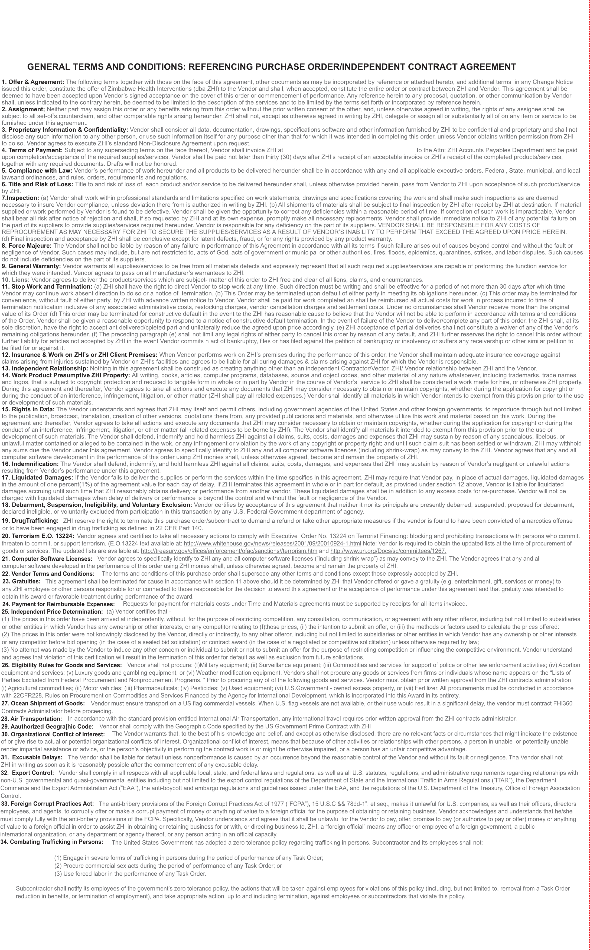
ATTACHMENT A: GENERAL TERMS AND CONDITIONS

