
Zimbabwe Health Interventions (ZHI)
Emerald Office Park Number 30, The Chase,
Corner 2nd St. Extension & The Chase (West)
Mount Pleasant, Harare, Zimbabwe

REQUEST FOR QUOTATION (RFQ)
FOR
SUPPLY AND DELIVERY OF LAPTOPS AND BACKPACKS

RFQ Number: | ZHI.RISE.2023.09.420
Submit Quotation to: | tendersrise@zhi.co.zw
Date of Issue of RFQ: | September 07, 2023
Firm Deadline for Quotations Submission and Time: | September 13, 2023, at 23:59pm
Approximate Date of Contract Award: | September 18, 2023

Method of Submittal:
Respond via e-mail to the email provided above, with attached quotation document in MS Word / pdf format. Documents should not be more than 2MB in size.

- INTRODUCTION
Zimbabwe Health Interventions (ZHI) is a local Zimbabwean non-profit human development organization whose mission is to help the Government of Zimbabwe achieve its health-related goals, with a focus on contributing to HIV/AIDS epidemic control using comprehensive and sustainable human development approaches; conducting research that will guide/inform policy and development of innovative interventions for human development in Zimbabwe. ZHI is currently implementing two 5-year programs funded by the US Agency for International Development (USAID). For more information, please visit www.zhi.co.zw.

- PURPOSE/SCOPE OF WORK
With funding from the United States Agency for International Development (USAID) for the DREAMS-
Re-ignite, Innovate, Sustain and Empower (RISE) project, the ZHI now invites potential and eligible service providers to submit comprehensive quotations for the Supply and Delivery of 100 (One hundred) Laptops and Backpacks in accordance with the specifications as indicated in the table below: (including at least 1-year warranty).

- MINIMUM TECHNICAL SPECIFICATIONS
The specifications prescribed below are not in any way limited to any specific tenderer as they are based on generally achievable requirements. Thus, minimum preferred specifications are as stated below: -
# | Specification | Description of Specification | Quantity
1. | Laptops |  | 100
 | Memory | 16GB
 | Operating System | Windows 11 Pro,
 | Processor | At least Intel(R) Core (TM) i7 CPU @ 3.0GHz 11th Generation
 | System type | 64-bit operating system, x64-based processor
 | Hard Drive | At least 512GB PCIe SSD
 | Battery | Up to 20 hours* 57Wh,
 | Battery | Rapid Charge technology available with 65W AC
 | Graphics | Intel UHD 620, NVIDIA® GeForce RTX™ 2050 Laptop GPU
 | Audio | Dolby Audio™ Premium
 | Audio | Dual far-field microphones
 | Camera | HD 720p with privacy cover
 | Camera | Optional: Hybrid Infrared (IR) with Shutter
 | Keyboard | Spill resistant
 | AC Adapter | 65W (required for Rapid Charge)
 | Connectivity | WWAN: Optional: Integrated Global Mobile Broadband LTE-A, Wi-Fi 6E AX211
 | Connectivity | WLAN: Intel® Dual-Band Wireless 2 x 2 AC
 | Connectivity | Bluetooth® 5.3pr
 | Connectivity | Ethernet
 | Connectivity | Optional: NFC
 | Ports/Slots | 1X Type C Port
 | Ports/Slots | 2 x USB 3.1 (Gen 1)
 | Ports/Slots | 1 x Ethernet port
 | Ports/Slots | 2 x USB-C (1 Thunderbolt™ 3)
 | Ports/Slots | Headphone / mic combo
 | Ports/Slots | HDMI 2.1
 | Ports/Slots | Combo MicroSD / Micro-SIM slot
 | Ports/Slots | Smart card reader
 | Display | 14 Inch
 | Language | English
 | Warranty | At least 1 year
2. | Laptop Bags |  | 100
 | Backpacks | 15.6-inch, main compartment with padding laptop pocket; compartment with mesh pockets; zipper side pockets and comfortable shoulder strap and back with padding.

- INSTRUCTIONS AND TERMS FOR BIDDERS

  - By submitting a bid, all Bidders certify that the person(s) involved in the preparation and collation of the quotation and/or quotes were or are in no way associated or have any Conflict of Interests with the initial preparation of the solicitation, the tender documentation, or the subsequent evaluation, assessment, analysis, management, and decision-making process of this tender.

  - Tenders MUST be received on or before the closing date and time and all bids received after the closing date and time may not be considered.

  - Language - the quote, as well as all correspondence and documents relating to the offer shall be in English.

  - The Quotation should include the following:
    - Price shall be quoted in US dollars (USD) only.

    - Prices for the requested services should be inclusive of all related costs include all associated costs.
    - Bid Validity Date - All information submitted in connection with this RFQ will be valid for ninety (90) days from the RFQ due date and not subject to variation on any account during the Bidder’s performance of the final Contract unless another time is specified in the addendum of the RFQ. This includes, but is not limited to items quoted, cost, pricing, delivery timelines, terms and conditions, service levels, and all other information.

  - To ensure that the same level of information is conveyed equally to all suppliers, ZHI reserves the right to share questions and responses with all other suppliers.

  - ZHI does not bind itself to accept the lowest tender price and reserves the right to reject all submissions, in whole or in part, enter into negotiations with any party, and/or award multiple contracts.

  - ZHI will issue a Purchase Order to the selected winner(s) that shall state the items to be purchased, the location to which the items should be delivered, the specific timeframe within which the order should be completed, and a fixed price for the items to be purchased (including delivery costs). The Purchase Order will become a legally binding contract when it has been formally signed by both ZHI and the winning Vendor. A full list of the Terms and Conditions of the final Purchase Order are included as Attachment A to this RFQ.

  - If your firm is awarded the contract, all information in the RFQ and negotiation process is contractually binding. No submission will be considered for any discovered omissions from the Bidder(s)

  - In case of failure by the Supplier to fulfil its obligations under the terms and conditions of this Purchase Order, including but not limited to make delivery of all the goods by the agreed delivery date or dates, ZHI may, after giving the Supplier reasonable notice to perform and without prejudice to any other rights or remedies, exercise one or more of the following rights:
4.9.1 Procure all or part of the goods from other sources, in which event ZHI may hold the Supplier responsible for any excess cost occasioned thereby.
4.9.2 Refuse to accept delivery of all or part of the goods.
4.9.3 Cancel this Purchase Order without any liability for termination charges or any other liability of any kind of ZHI.

  - All responses and supporting documentation shall become the property of ZHI and will not be returned.

- EVALUATION CRITERIA AND SUBMISSION REQUIREMENTS
ZHI will accept submissions from reputable qualified vendors and the quotations will be reviewed, evaluated, and scored based upon the criteria stipulated below. Please submit or include with your application for each Evaluation Criteria anything that will help ZHI to fully evaluate your submission on each individual criterion.:

5.1 Evaluation Criteria
The final selection will be based on the Lowest Priced Technically Acceptable bid that meet the mandatory requirements outlined in the solicitation, with well-defined and clear specifications. Each bid should contain the items listed in the Submission Requirements column and should be submitted in the order they appear below.

Evaluation Criteria | Submission/Evaluation Requirements | Weight
Mandatory Requirements for Supplier | All applicants are required to submit the following:  - Company profile (clearly stating physical address, tel. no., fax no.’ corporate e-mail address)  - Certificate of registration/incorporation  - Valid Tax clearance certificate/VAT registration (for local suppliers)  - Bank account details  - A minimum of three (3) verifiable current/previous clients (references), preferably in the NGO sector. | Pass/Fail
Laptops and Backpacks | - Detailed technical specification of the proposed laptops must be provided responding to the specifications described in this RFQ document, including warranty.  - Provide Photos of both the laptop and backpack if available | 60%
Price | A Quotation which should be in US dollars  - The price should be inclusive of all applicable taxes.  - Any discounts given | 20%
Delivery and Payments Terms | Provide information on the following:  - Payment terms  - Availability and delivery timeline (Bidders are required to commit delivery by 30 September 2023) | 20%
 | TOTAL: | 100%
Failure to provide any of the above Submission Requirements may be considered non-responsive and disqualify the applicant from final selection.

- SUBMISSION INSTRUCTIONS
All bids MUST be submitted by 23:59pm on September 13, 2023, via email to: tendersrise@zhi.co.zw. The bids MUST be received on or before the closing date and time and any bids received after the closing date and time may not be considered.

- ETHICAL BEHAVIOR
Zimbabwe Health Interventions (ZHI) adheres to the highest standards of ethics, honesty and integrity as part of its corporate governance initiatives. ZHI believe that ethics, honesty and integrity are foundations for healthy business practices, and expects its business partners to do the same. ZHI has ZERO tolerance for fraud, theft, corruption, kickbacks undisclosed conflicts of interest especially in its procurement processes which ZHI endeavours to ensure are open, fair and allow for equal opportunity to all service suppliers including small and women led organisations.

Therefore, if you experience or suspect unethical behaviour by a ZHI employee, please contact the ZHI’s Deloitte Tip-offs Anonymous on: Toll free cell: 0808 5500/ 4461 (Econet Subscribers Only) Toll free cell: 0716 800 189/ 0716 800 190 (Netone subscribers only) Toll free cell; 0732 220 220/0732 330 330 (Telecel subscribers only) WhatsApp: 0772 161 1630 and on e-mail: reportszw@tip-offs.com
Any vendor/consultant who attempts to engage, or engages, in corrupt practices will have their quotation disqualified and will not be solicited for future work.

- TERRORISM
ZHI shall use its best endeavours to ensure that funds provided under this tender do not provide direct or indirect support or resources to organizations and individuals associated with terrorism, promote or advocate the legalization or practice of prostitution or sex trafficking and assistance to drug traffickers. If, during the course of this tender, ZHI discovers any link whatsoever with any organization or individual associated with any or all of these, they shall be excluded or disqualified from the tendering process. Bidders will also be verified if they are not listed on database of restricted/debarred suppliers.

ZHI EQUAL EMPLOYMENT OPPORTUNITY STATEMENT
ZHI is an equal opportunity employer and employs personnel without regard to race, ancestry, place of origin, colour, ethnic origin, language, citizenship, creed, religion, gender, sexual orientation, age, marital status, physical handicap or financial ability.

- ZHI RIGHTS AND DISCLAIMERS
  - ZHI reserves the right to disqualify any offer based on failure of the offeror to follow solicitation instructions
  - ZHI may cancel the solicitation and not award
  - ZHI may reject any or all responses received
  - Issuance of the solicitation does not constitute an award commitment by ZHI
  - ZHI will not compensate any offeror for responding to solicitation
  - ZHI reserves the right to issue award based on initial evaluation of offers without further discussion
  - ZHI may choose to award only part of the activities/items in the solicitation, or issue multiple awards based on the solicitation activities/items
  - ZHI reserves the right to waive minor quotation deficiencies that can be corrected prior to award determination to promote competition.

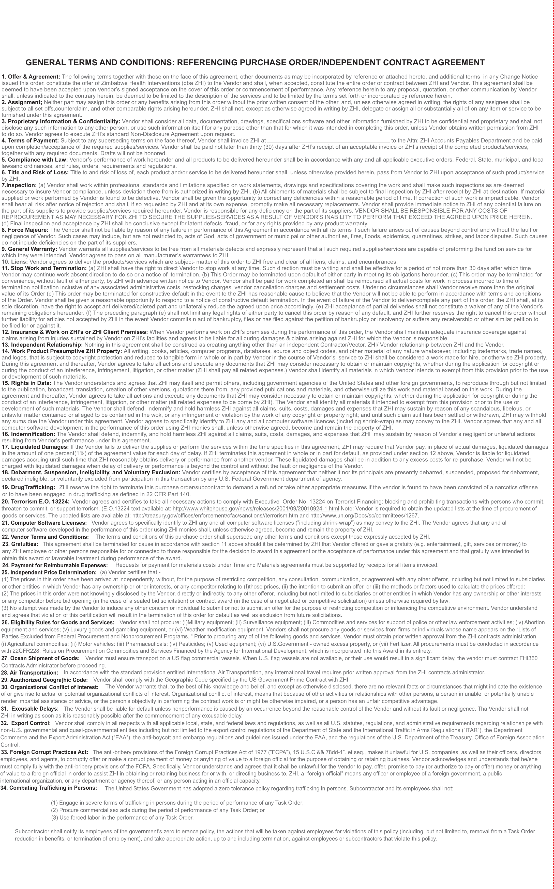
ATTACHMENT A: GENERAL TERMS AND CONDITIONS

